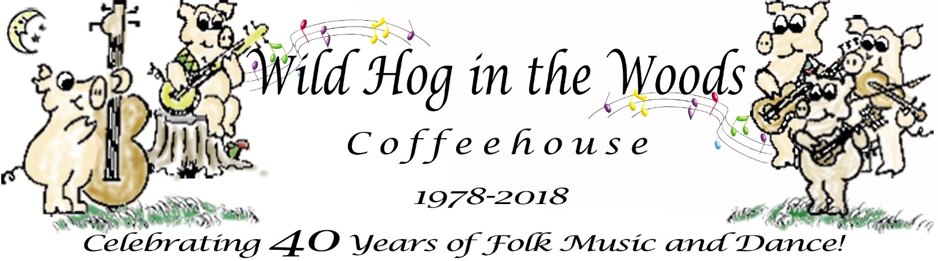
953 Jenifer Street, Madison, WI 53703 www.wildhoginthewoods.org

Press Release
Contact: Jamie Diana Poindexter  Phone: (608) 850-9556  Email: jamiep@wildhoginthewoods.org | FOR IMMEDIATE RELEASE  July 9, 2018

local Folk Music Organization celebrates 40 years
Madison, Wisconsin, JULY 9, 2018: The Wild Hog in the Woods Coffeehouse is celebrating its 40th anniversary with a barn dance in Olin Park on July 21st and special concerts during our Fall season at our location inside of the Wil-Mar Neighborhood Center at 953 Jenifer Street.

Barn Dance, Saturday, July 21:
The Barn Dance will be held in the Olin Park Pavilion (Barn)starting with a potluck dinner at 5:00 PM, Saturday, July 21st. Dance starts at 7:00 PM. Live music by members of Rattletrap, Lakeview Ramblers, and Stone Soup and calling by Roger Diggle and Mike Mossman. Suggested donation of $10 admission. Details are at www.wildhoginthewoods.org

Irish Singer/Songwriter Aoife Scott on stage September 7:
The Hog’s Fall Season opens Friday, September 7th with Irish folk singer Aoife Scott at 7:30 PM. Aoife recently won Best Irish Folk Act 2018 awarded by the Irish Post. See https://www.irishpost.com/news/aoife-scott-wins-best-irish-folk-act-at-the-irish-post-music-awards-155761

Aoife is the daughter of singer-turned-politician Frances Black and niece of folk singer Mary Black, both of whom performed with their brothers in the Celtic ensemble The Black Family. For Scott, playing music helps connect her to people on a much deeper level. The bonds she has forged through her debut album “Carry the Day,” which was released in 2016, have lasted the past two years, long past when her first U.S. tour ended last year.

Additional concerts, which are held Friday’s at 7:30 PM in our space at the Wil-Mar Neighborhood Center are being booked. Watch for the schedule on our web site and in local newspapers.

Anniversary/Birthday Party, November 30:
The Wild Hog in the Woods first opened on November 30, 1978. This year, Friday November 30 is our 40th Anniversary/Birthday Concert-in-the-Round, featuring multiple musicians and singer/songwriters of folk music coming together to share the stage. Lisa Johnson, KG and the Ranger, and Roxanne Neat have already signed up to perform. Others to be announced. Special start time to be announced. Pizza and birthday cake will be served in addition to our usual coffee, teas and flavored waters.

Our 40 Year History
In the spring of 1978, several folk enthusiasts began talking about possible outlets for folk music beyond their living rooms and record players. In particular, they wondered about finding a location which would be permanent and open to the public, a place where folks could go to hear or play folk music even if they did not know anyone in town.

Kiosks and store fronts were postered around town to find other interested people. The consensus at the early meetings was that the place should be a coffeehouse.

Later meetings led to our incorporation as a non-profit, non-stock organization and also to organize as a cooperative. With Madison’s strong cooperative community and with a healthy concern against ‘going in over our heads’ as a commercial venture, we determined that a cooperative would be the way to go, the safest economically, and the fairest socially.

It’s been determined over and over again that a broad base of ideas and personal support is important for the operation and long life of the Wild Hog.

What is the Wild Hog in the Woods?
The Wild Hog in the Woods is a membership organization, a not for profit based on cooperative principles that was started by musicians in 1978 when there were not many venues to play their songs.

The Wild Hog operates a 60’s style coffeehouse with live folk music and other special events, workshops, dances from time to time or in cooperation with other organizations.

Members play a big role in the Wild Hog, volunteering their time to host the coffeehouse and other events, including promotion, booking performers, running sound, baking, newsletter and web site, and much more. We welcome new members!

A good way of getting involved with the Coffeehouse is by volunteering some of your time. We always need help with setup, take-down, and the like. There are many behind the scenes jobs such as baking and scheduling, which can be done on a more flexible schedule.

If you’re interested in performing at the coffeehouse, playing or calling at a barn dance, becoming a member, or would like to get involved with the Coffeehouse in any way, you can simply talk to the MC or person at the admission table or contact our scheduler listed on the web site, www.wildhoginthewoods.org.

Performers play for tips placed in our ceramic wild hog, Phillup-the-Pig. Staff are all volunteers. That’s what allows us to keep the admission low, just to pay the rent.

Often the Wild Hog in the Woods Coffeehouse joins forces with other organizations in the area to accomplish common goals that neither group could bring about as well (if at all) alone.

The reasons for this are to foster an atmosphere of community, and of mutual support, as well as to expose a vast range of ideas, musical styles, and cultural and ethnic flavors to a more diverse cross section of people. We really think cooperation is a good idea and we love to do it.

PreSS KIT available:

This press release and selection of photos:
http://wildhoginthewoods.org/Anniversaries/2018/PressKit/index.html

-End-

