Celebrating 40 years of

Folk Music,

Dance, and storytelling

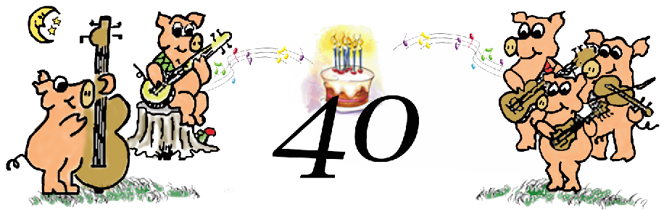**Wild Hog in the Woods**

**Coffeehouse**

**Friday, November 30, 6-10pm**

**Pizza and Birthday Cake at 6pm**

**Round Robin Music Jam at 7pm**

**with Gordy Hinners, Pete Houser, Jamie Hascall,**

**KG and the Ranger, Roxanne Neat, Lisa Johnson,**

**Skip Jones, Stephen Lee Rich, and others**

**953 Jenifer Street (Wil-Mar Neighborhood Center)**

**www.wildhoginthewoods.org**